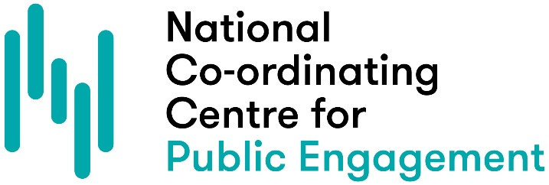

MY PUBLIC ENGAGEMENT BLUEPRINT
Use this template to map out your own public engagement blueprint. Think of it as a space to capture ideas. Don’t worry if some of the questions are hard to answer right now.

WHY? (PURPOSE)
What difference am I trying to make?

WHO? (PEOPLE)
Who am I trying to engage with my research? Why would they want to engage?

HOW? (PROCESS)
What methods will I use to engage people with my research and when? How will I maximise involvement?

EVALUATION
What do I hope to learn from my evaluation? How will I evidence outcomes / impact?

