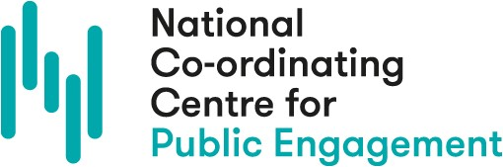

Date:

Action Learning Reflective Journal
Is there any framing or contextual information you would like to note for this entry? |  | How do you feel about the action learning process right now?
What is going well? About the action learning process? About the impact on your work?
Is there anything that could be different or that you would like to change? About the action learning process? About the impact on your work? Is there anything you need to do about this?
What have you learnt so far? This might be personal or professional areas of growth.
What do you hope or plan to do next through this process? |  | Is there anything else you would like to note?

