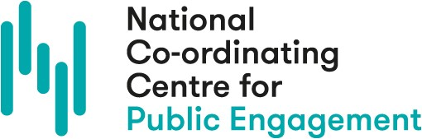

The high quality engagement framework in practice
So how can you put the framework to use to plan your own engagement activity?

1. What purposes do you have for your engagement work?
Consider the purpose of your engagement work, and the difference you could try to make. You may find it helpful to think about different frameworks, such as the NCCPE Impacts Framework or generic learning outcomes framework.

2. Who might you involve or engage with?
How will you identify the people to engage: demographics, interests, attitudes, behaviours? Why did you choose them?

Consider stakeholders and partners. Who is already working in this space? Who could you work with or align your work to? Who else should or could be involved, informed or consulted about this project? List your potential stakeholders and partners and highlight those you would like to work with.

Activity: Consider your research engagement project. Jot down some hooks they could use to get people invested, excited, or at least intrigued in this project. Do any particularly resonate with the people you have identified to involve?

3. What methods could you use?
Make sure the methods chosen fit with your purpose and the people you hope to engage with, as well as the skills or capacity you (and your team) have to deliver that approach. Timeline and budget are often limiting factors, but don’t let this stymie you! Give yourself space for creativity…
Activity: Take a blank sheet of paper. In separate bubbles, write down the purpose (why?) and people (who?) you could involve in your project. Take 3-5 minutes to brainstorm methods of engagement or project ideas across the research cycle. You can refer to the research cycle activity diagram for ideas.
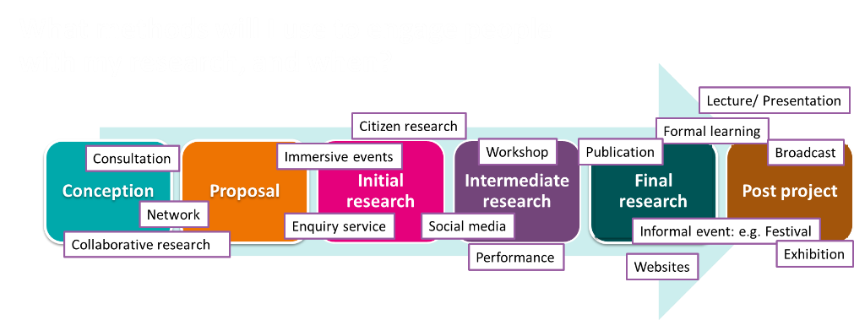
Which of these serve your purpose? Which of these best suits the people involved? Connect these and see what possibilities emerge. If you find there’s a disconnect between people and purpose, step back and assess if the people you have identified match the purpose you originally chose.

What methods will you use to engage people and when? Is there a festival, project or other event you could work with? Have you considered the project management, such as budget, risk assessment, and ethics?

4. What are the measures that this project was a success?
What are your measures that this project is a success? How will you plan to evaluate your work? How will I evidence impact? How else could evaluation help and/or inform your work?

Iterative questions
As your project develops, also consider if it is meeting the purpose you set out. Are your processes fit for the purpose and people? What improvements could/should you make?

Look back at your project development so far. Is there anything you would clarify, add or refine?

